National University of Computer and Emerging Sciences


CS2016 - Programming for Business
FAST School of Management CFD-Campus
BS-FinTech -2A
Final Project Report PFB

Hamza Saleem (24F-5529)
Taha Adnan (24F-5521)
Ali Husnain (24F-5518)

Restaurant Management System – Project Report

Description:
The Restaurant Management System is a Python-based console application designed to streamline restaurant operations. Its primary purpose is to help restaurant staff manage menu items, take customer orders, and generate essential reports such as sales and inventory. The system is menu-driven and user-friendly, making it suitable for small to medium-sized restaurants.

Key Features:
Menu Management: Add, update, and remove dishes from the menu, including details like category, price, and ingredients.
Order Processing: Take customer orders by selecting dishes and quantities, automatically calculating totals and tax.
Reporting: Generate sales and inventory reports to track revenue and stock levels.
Inventory Tracking: (Basic) View current inventory items and their quantities.
Simple & Detailed Menu Views: Display the menu in both summary and detailed formats.

Sample Outputs:
- Adding a Dish
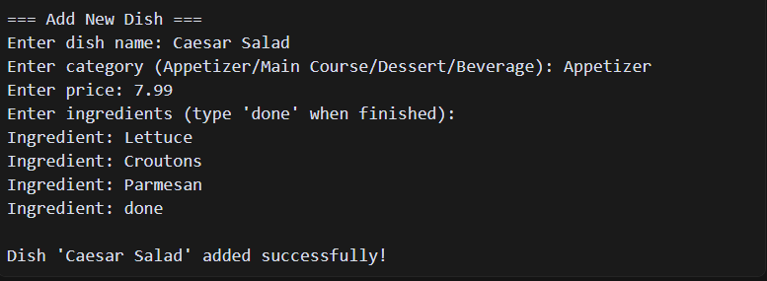
- Placing an Order
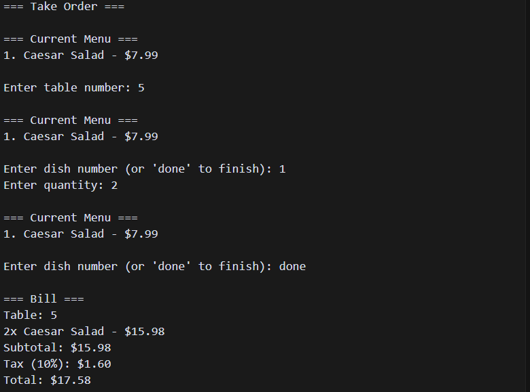
- Generating a Sales Report
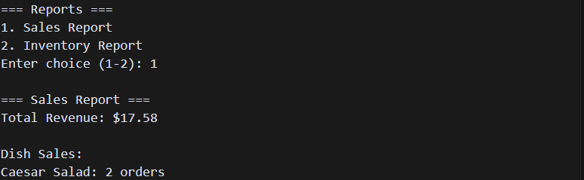

Challenges & Solutions:

1. Managing Data Structures:
Challenge: Storing menu items, orders, and inventory in a way that is easy to update and retrieve.
Solution: Used lists of lists to represent menu items and orders, allowing for flexible addition, update, and removal operations.

2. User Input Validation:
Challenge: Ensuring the program handles invalid inputs (e.g., non-numeric values for price or quantity).
Solution: Added checks and prompts to guide the user, and used type conversion with error handling where necessary.

3. Dynamic Menu Display:
Challenge: Displaying the menu in both simple and detailed formats without code duplication.
Solution: Created two separate functions (show_current_menu and show_menu) to handle different display requirements.

4. Calculating Sales and Tax:
Challenge: Accurately calculating order totals, including tax, and aggregating sales for reports.
Solution: Implemented subtotal and tax calculations within the order-taking function and aggregated sales data in the reporting function.

